**03. Functional Testing:**

|  |  |  |  |  |  |
| --- | --- | --- | --- | --- | --- |
| **No** | **Title** | **Test Steps** | **Expected Result** | **Actual Result** | **Action Taken** |
| 3.1 | Functional Testing(Making Enquiries) | Peoples send their query by filling up enquiries form. | The query from users will be saved on the database with their details. | Queried data successfully stored on the database. | None |
| 3.2 | Functional Testing  (Page link send by email) | Send any page details by email by using Send by email button. | The page link of the system will be shared by mail with the provided email address with optional message. | Page details shared successfully. Got An email from system user with the page details and the test was successful. | None |

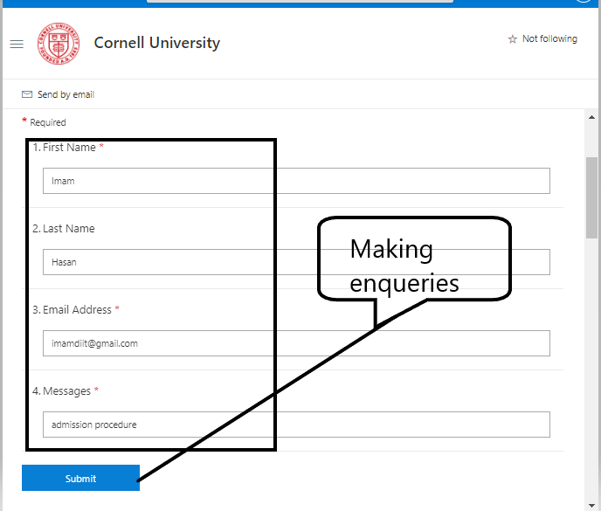

Figure : Making Enquiries

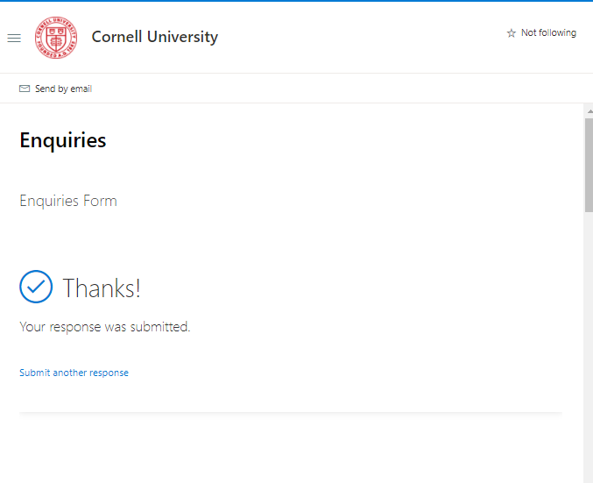

Figure :A message shown

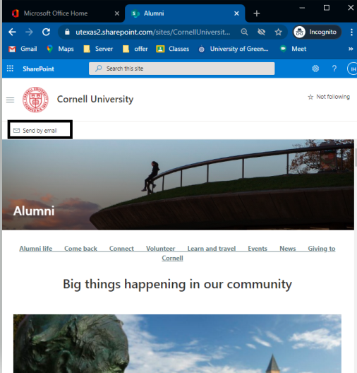

Figure : Sending page link through Gmail

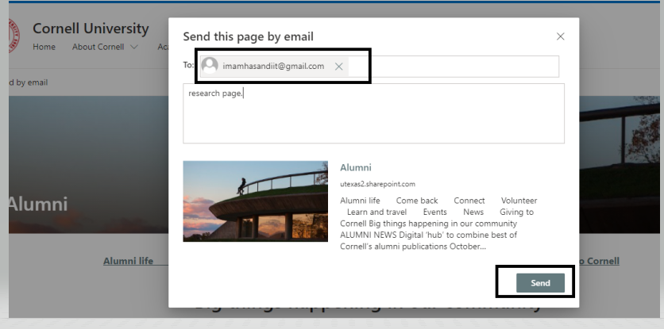

Figure : link will be sent after clicking on send button.